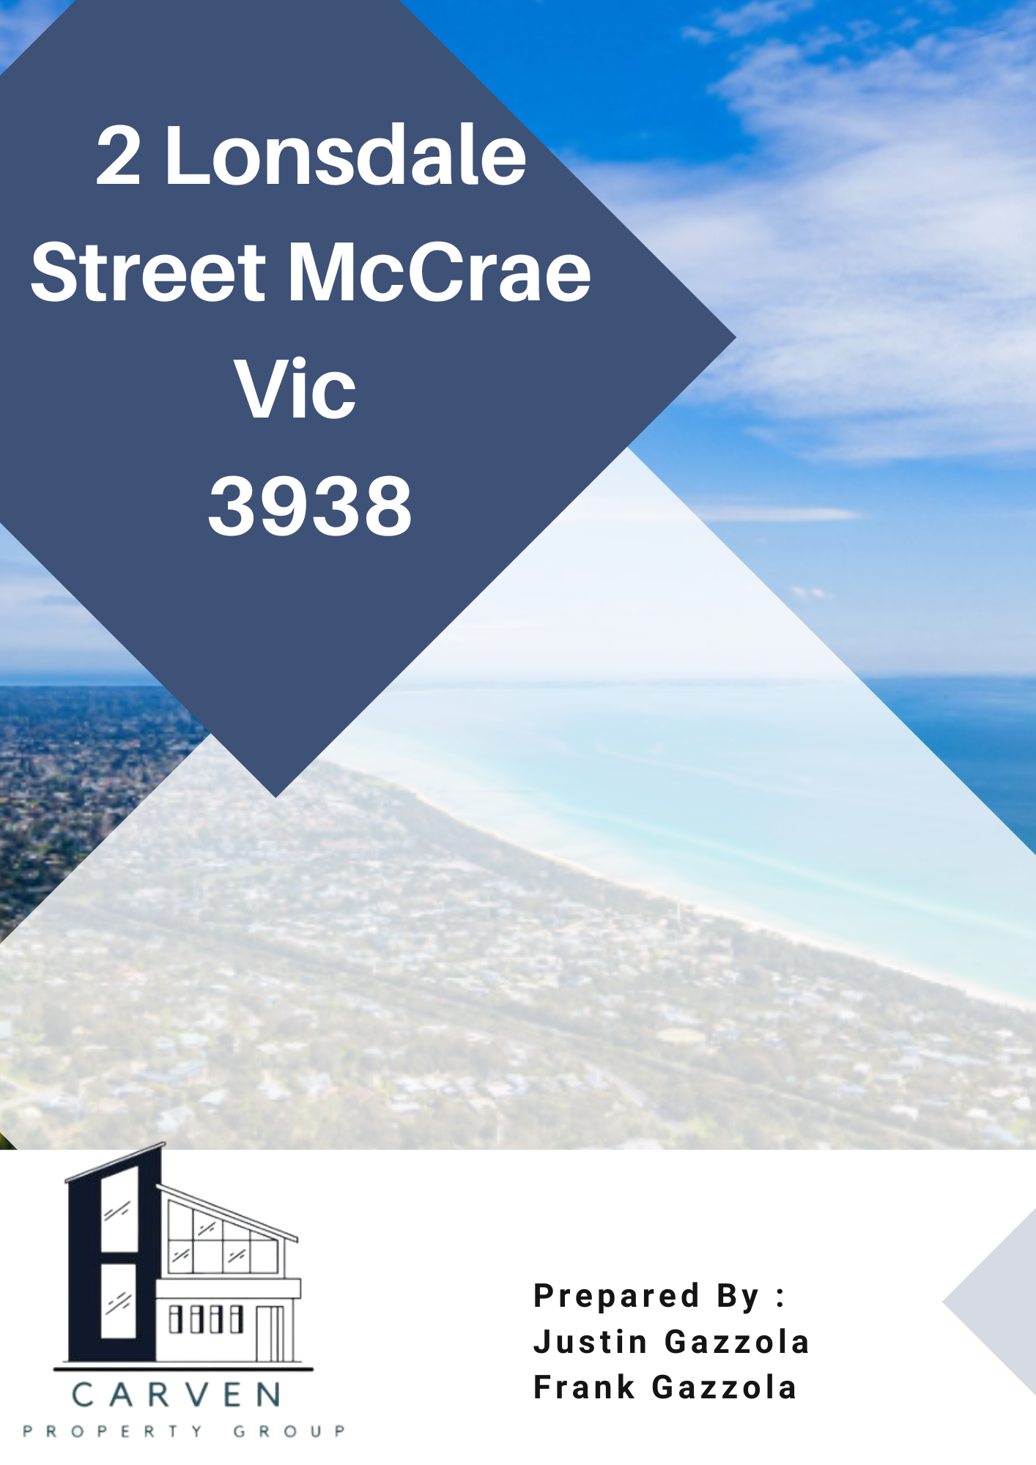

## 

Contents

**Project- 2 Lonsdale Street McCrae** 3

**Locality & Site Details** 4

**Other Information** 5

**Investment Structure (example)** 7

**Plans and Pictures (An Example)** 8

# **Project- 2 Lonsdale Street McCrae**

Carven Property Group and AMG Homes Pty Ltd are excited to offer you the opportunity to invest in a residential property development featuring a large holiday beach house at 2 Lonsdale Street, McCrae, located approximately 59 km south of Melbourne CBD. This development presents an attractive investment option for individual investors, Self-Managed Super Funds (SMSFs), and other investment structures, such as family or investment trusts.

We are seeking to raise $900,000 from investors, with an anticipated return of 8%. The investment is projected to deliver this return on a non-compounding annual basis, with a completion timeline of 12 to 24 months. Both interest and capital will be paid upon the sale of the property. The Director of the company brings extensive experience in property development, having managed and advised on multiple projects, offering valuable insights into the evolving property market and trends in demand.

As with any property development investment, there are risks involved, and we strongly recommend you seek independent financial advice before proceeding.

# **Locality & Site Details**

Located in the picturesque Mornington Peninsula, 2 Lonsdale Street, McCrae, lies within the Shire of Mornington Peninsula, approximately 90 km south of Melbourne's CBD. This property is nestled in a quiet residential neighbourhood, offering easy access to the serene McCrae Beach, renowned for its calm waters and family-friendly vibe, and is just a short walk from the historic McCrae Lighthouse. Nearby amenities include McCrae Plaza, with convenient access to the Mornington Peninsula Freeway, making travel to surrounding areas effortless. The property likely features flat terrain typical of the region, with direct access via peaceful Lonsdale Street. Surrounded by a blend of established homes and new developments, this site offers a highly desirable coastal lifestyle, with potential views or breezes from Port Phillip Bay due to its close proximity to the foreshore.

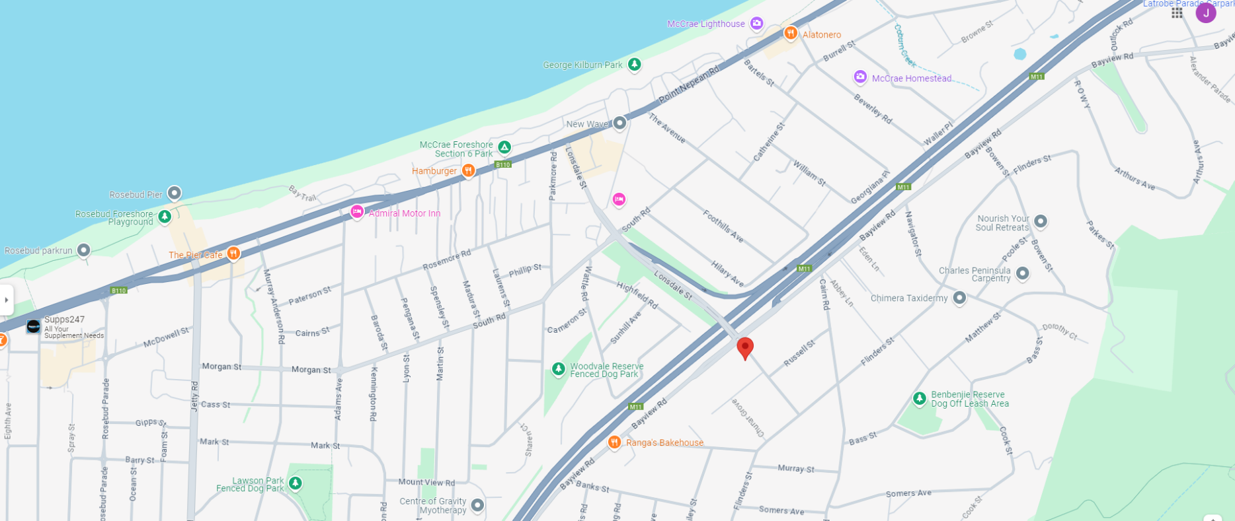

# **Other Information**

**FUND STRUCTURE**

The fund is an unregistered managed investment scheme structured as a unit trust established by the Trustee according to the Trust Deed and is governed by Australian law

**FUND PURPOSE**

To raise Capital from investors through the issue of Units and to provide this Capital by way of debt instruments to the Property Developer supporting the procurement of the development approvals and carrying out of the development at 2 Lonsdale Street, McCrae. A separate Class of Units may be issued to investors with the Project to reflect different terms. Different terms, including target returns, may be negotiated with each Investor

**INVESTMENT OBJECTIVE**

Generate an attractive return through the provision of working Capital by way of loan facilities to the Property Developer

**INVESTMENT RETURN**

A 8% return will be distributed to each Investor based on their Capital invested.

E.g., $200,000 Invested, 8% Return on $200,000 = $15,000

Amount returned to investor = $215,000

**INVESTMENT PERIOD**

The time frame of the investment will be 12 -24 Months months from the day the construction begins

**DISTRIBUTIONS**

Distributions are unlikely to be made during the Investment Term. The Trustee anticipates making distributions once the property developer sells all properties.

**MINIMUM INVESTMENT**

The minimum initial investment is $20,000.00. The Trustee has the discretion to accept smaller amounts

**INVESTMENT TERM**

As a "closed-end" project-specific Fund, the investment term will be determined by the timeframe for the Property Developer to complete construction and realise sales.

The expected investment term is approximately 12-24 Monthsmonths, after which the Trustee proposes to wind up the fund. The Trustee may extend or shorten the Investment Term as necessary to complete the Project.

**FINAL CLOSE**

When fully subscribed or at the discretion of the Trustee. The Trustee retains the right, in its absolute discretion, to raise additional Capital after the final close where required

**INVESTMENT MANAGER**

Carven Property Group Pty Ltd (642 178 890)

4

**PROPERTY DEVELOPER**

AMG Homes P/L, the property developer and the borrower of funds from the fund

**PROJECT MANAGER**

AMG Homes P/L (ACN 147 477 165)

**Financial Advice**

Considering the risks associated with investing in Property Development would be best.

Therefore, you should seek your independent Financial Advice before investing in this Property Development.

**TAX COMPLIANCE**

The fund retains the services of FJG Partners as the funds business advisor and tax advisor. FJG Partners provides the breadth of accounting services necessary for the fund with property development business specialists. In addition, FJG Partners are engaged to ensure the fund addresses any reporting, tax, and auditing obligations of the fund.

5

# **Investment Structure (example)**

# 

**The investors will lend to Carven Property Group**

**Carven Property Group**

**Investor 1**

**Investor 2**

**Investor 3**

**Then Carven Property Group lend to the property developer**

**Investor 4**

**Investor 5**

**Property Developer**

**(AMG Homes)**

**Investors investing in Property Development**

**Investors Amount Invested Interest % Interest**

Investor 1 $300,000.00 8% $24,000.00

Investor 2 $200,000.00 8% $16,000.00

Investor 3 $100,000.00 8% $8,000.00

Investor 4 $100,000.00 8% $8,000.00

Investor 5 $100,000.00 8% $8,000.00

**Total Invested $800,0000 $64,000.00**

The Investor will be returned a 8% fixed interest return based on an investment period of 1 year or/24 months. The Investor will be distributed funds based on what they invested once the properties are sold. They will receive the Capital plus interest.

*The Investor can be an Individual, Partnership, SMSF or a Company/Trust.

# 

# **Plans and Pictures (An Example)**

